**Class and Object Basics**

1. Create a empty class.

class Arun:

pass

ob=Arun

1. Perform the following operation for the class
   1. Create a class with variables and methods of public category.
   2. Create Object for the class.
   3. Access the class variables and methods with the created object

class python:

a=15

b=10

def add():

print("add")

def sub():

print("Sub")

ob=python

ob.add()

ob.sub()

print(ob.a)

print(ob.b)

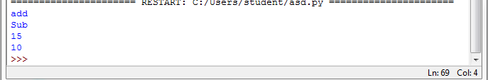

1. Perform the following operation for the class
   1. Create a class 'Sample' with variables (x,y,z) and assign the value to the variables  
      3.2 Write a methods (display() to display the value of x,y,z) of public category.  
      3.3 Create the object for the class Sample and call the display method  
      3.4 With the object access the variables x,y and z outside the class.

class Sample:

x=15

y=10

z=12

def display(self):

print("inside display")

print("X=",self.x,"Y=",self.y,"Z=",self.z)

pass

ob=Sample()

ob.display()

print(ob.x)

print(ob.y)

print(ob.z)

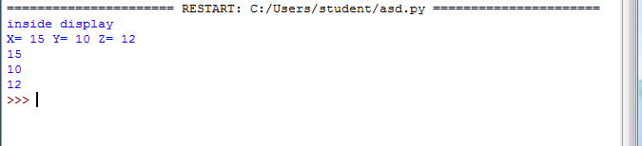

1. Perform the following operation for the class  
   4.1 Create a class 'Sample' with variables (x,y,z of private category) and assign the value to the variables  
   4.2 Write a methods (display() to display the value of x,y,z) of public category.  
   4.3 Create the object for the class Sample and call the display method  
   4.4 With the object access the variables x,y and z outside the class.

class Sample:

__x=15

__y=10

__z=12

def display(self):

print("inside display")

print("X=",self.x,"Y=",self.y,"Z=",self.z)

pass

ob=Sample()

ob.display()

print(ob.__x)

print(ob.__y)

print(ob.__z)

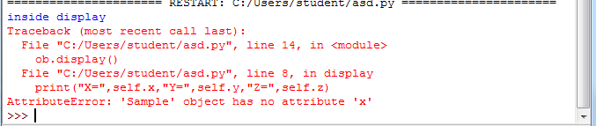

1. Perform the following operation for the class  
   5.1 Create a class 'Sample' with variables (x,y,z of private category) and assign the value to the variables  
   5.2 Write a methods (display() to display the value of x,y,z) of private category.  
   5.3 Create the object for the class Sample and call the display method  
   5.4 With the object access the variables x,y and z outside the class

class Sample:

__x=15

__y=10

__z=12

def display(self):

print("inside display")

print("X=",self.__x,"Y=",self.__y,"Z=",self.__z)

pass

ob=Sample()

ob.display()

print(ob.__x)

print(ob.__y)

print(ob.__z)

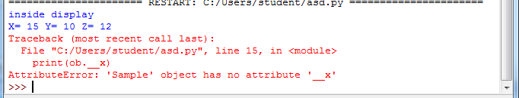

1. Perform the following operation for the class  
   6.1 Create a class 'Sample' with variables (x,y,z of private category) and assign the value to the variables  
   6.2 Write a methods (display() to display the value of x,y,z) of private category.  
   6.3 Write a method (calldisplay() to call the display method) of general category.  
   6.4 Create the object for the class Sample and call the calldisplay method

class Sample:

__x=15

__y=10

__z=12

def display(self):

print("inside display")

print("X=",self.__x,"Y=",self.__y,"Z=",self.__z)

def calldisplay(self):

self.display()

pass

ob=Sample()

ob.calldisplay()

